FIELD REPORT
Introduction
- Place: AYER HC III
- Location: Lwara, Kole district
- Date of visit: 25th August 2026
- General observations
The health facility currently operates from two main buildings. The maternity block accommodates the postnatal/labor ward, labor suite, and a makeshift laboratory. The remaining departments are housed within the older building, which is relatively small and accommodates several service areas.
The facility continues to face space constraints, particularly within the older building (very small), where multiple departments operate within limited space. During the visit, some areas of the building proved to be appeared small and congested, with limited ventilation and working space. The limited infrastructure presents challenges for the effective organization and delivery of services.
The laboratory does not have a fully dedicated space. A section of the maternity block has been partitioned to provide space for laboratory activities; however, the arrangement provides limited privacy and space for conducting laboratory tests and related activities.
2. Storage and accessibility of assets
The facility store was relatively small and was also being used for the storage of medicines and other supplies. At the time of the visit, the store was considerably congested, with limited space to access and clearly inspect the items stored inside. This constrained the team's ability to conduct a comprehensive physical assessment of assets kept in the store.
In addition, the staff available during the visit were relatively new to the facility and had limited information on the UGIFT support. Their limited familiarity with the project reduced the amount of historical information that could be obtained during the verification exercise.

Special note
Asset verification and supporting documentation
The physical verification of UGIFT-supported assets was affected by the absence of a clear and comprehensive asset register to guide the exercise. The team obtained a Bill of Quantities (BoQ) from the District, which was used as a reference to verify some of the assets at the facility.
The assets observed at the facility had no project-specific engraving or identification marks. Consequently, it was not possible to independently distinguish all UGIFT-supported assets from other assets at the facility based on physical identification alone.
The facility in charge was not present during the visit, and attempts to reach the person in charge by phone were unsuccessful. The verification was therefore conducted with the support of staff who were present at the facility. The staff indicated that many, if not all, of the UGIFT-supported assets received were currently being used within the maternity block and were therefore not kept in the store.
The facility staff also reported that an inventory book is used to track the functionality and status of assets. However, the inventory book was locked away and was not accessible during the visit; therefore, the team was unable to review it as part of the verification exercise.

The table below illustrates some physical status of the verified assets with photographic evidence.
Table XXX: Physical verification photos
MATERNITY BLOCK-FRONT VIEW (HOUSING THE LABOR SUITE, MAKESHIFT LAB, POSTNATAL WARDS) | 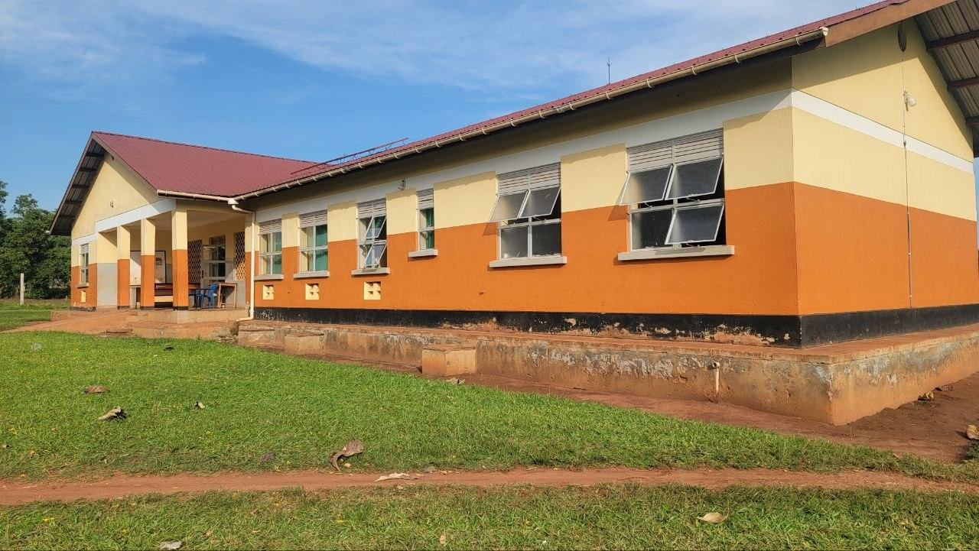
MATERNITY BLOCK-BACK VIEW (TANKS) | 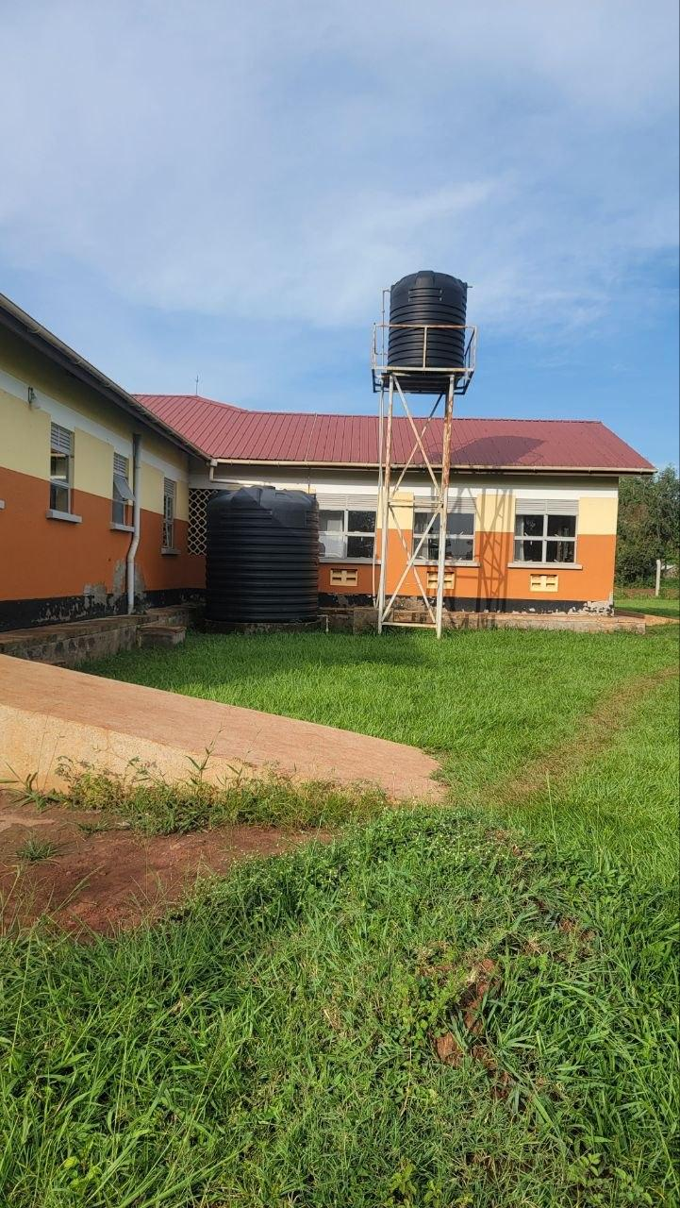
TYPICAL SET OF PATIENT’S TOILETS BLOCK (FOUR STANCES MALE AND FEMALE EACH TOILET) | 